The Colourful Butterfly Classroom Newsletter 2
Some of your child’s learning during the month of October...
English Rhymes  Flutter, Flutter Little Bat  Flutter, flutter little bat,  How I wonder where you’re at.  Swooping through the darkest night-  You find your way without a light.  Flutter, flutter little bat,  How I wonder where you’re at!  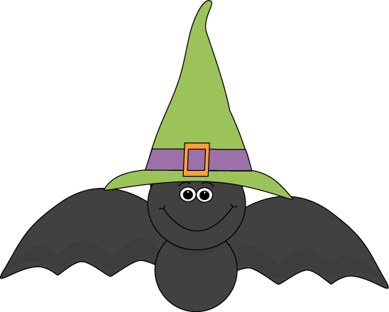  Who’s That Knocking?  Who’s that knocking on my door?  I must admit I’m a little scared.  I open it and what do I see,  A scary old witch and she’s laughing at me.  Who’s that knocking on my door?  I must admit I’m a little scared.  I open it and what do I see?  A green eyed monster and his growling at me!  Now i’m walking out that door, i’m not going to be scared no more!  Music  Song Singing  - Witch’s Brew  - Holly The Hedgehog .  -Leaves  Explore instruments.  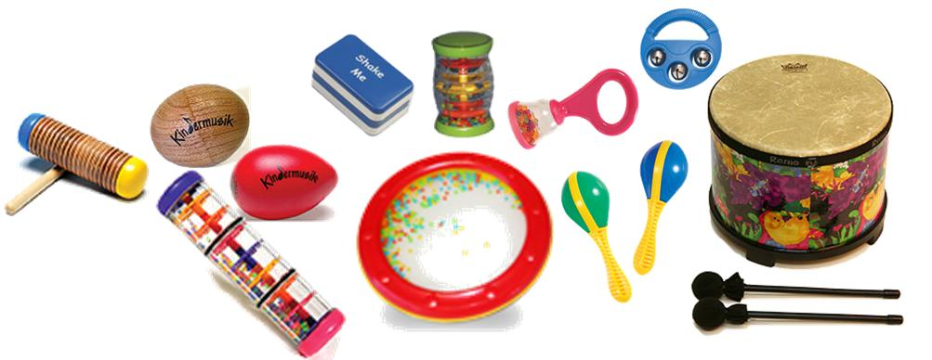  S.P.H.E.  Myself & Others  -All pupils will listen & participate in group activities to help assist special relationships form. | Story  *Room On The Broom  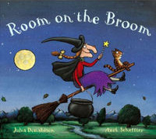  Your child will focus on this story through their senses for the month of October. He/she will develop awareness of & ability to manipulate objects that represent familiar people or objects from the story “Room On The Broom.”  Colour  -Black.  Visual Arts  -Print making using materials from the environment.  -Handle natural objects for experience of texture & pattern.  -Print making using parts of the body.  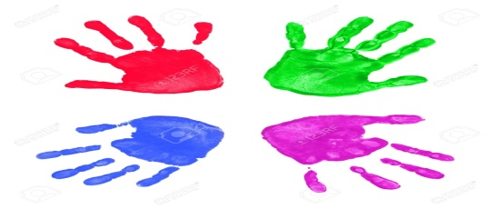  S.E.S.E.  Geography  -All pupils will become aware of natural materials in the local environment.. | Maths Rhymes  Five Little Ghosts  Five little ghosts knocked at the door,  Then one flew away and that left four.  Four little ghosts up in a tree,  Then one flew away and that left three.  Three little ghosts drinking witches brew,  Then one flew away and that left two.  Two little ghosts having lots of fun,  Then one flew away and that left one.  One little ghost now all alone,  He got bored so he flew back home.  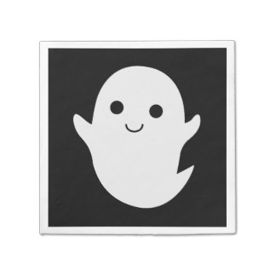  Notes For Parents.  Please bring the following to the school for your child (as soon as possible):  A (very) large old t shirt for painting with child’s name on it  Items for the Colour Display Table:  Black items: e.g. A black toy  A picture of your family

