The Colourful Butterfly Classroom Newsletter 3
Some of your child’s learning during the month of November...
English Rhymes  Warm Mittens  I wiggle my left hand,  I wiggle my right,  Inside of my warm mittens so warm and so tight.  I wiggle my pinkie,  I wiggle my thumb,  So when I make snowballs  My hands don’t go numb. 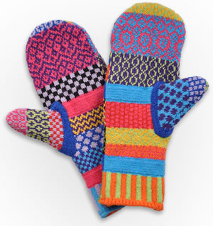  November  In November  Dark comes soon.  We turn on the lights  In the afternoon.  Now the Autumn days are gone  Frost is sparkling on the lawn.  Windows winking cheerful lights  Warm the cold November nights.  Music  Song Singing  -Walking In The Jungle.  -It’s Wintertime.  Explore instruments.  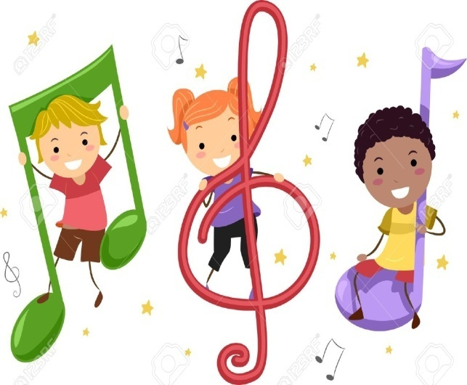  S.P.H.E.  Myself & Others  -All pupils will listen & participate co-operatively in activities with trusted adults. | Story  *The Tiger Who Came To Tea  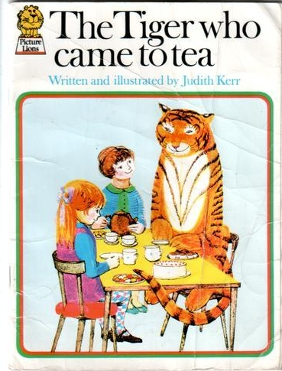  Your child will focus on this story through their senses for the month of November. He/she will develop awareness of & ability to manipulate objects that represent familiar people or objects from the story “The Tiger Who Came To Tea.”  Colour  -Orange.  Visual Arts  -Pupils will participate in making shapes with clay.  -Pupil will manipulate the clay to form a Tiger.  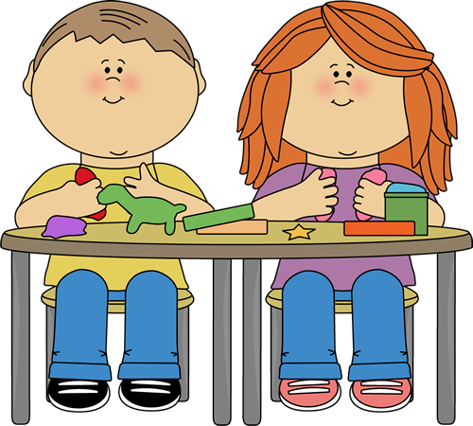  S.E.S.E.  Geography  -All pupils will become aware of different rooms in a house.  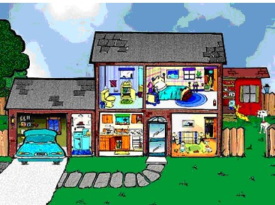 | Maths Rhymes  Walking In The Jungle  Walking in the jungle.  Walking in the jungle.  We’re not afraid, we’re not afraid.  Walking in the jungle.  Walking in the jungle.  We’re not afraid, we’re not afraid.  One step. Two steps, Three steps forward.  One step. Two steps, Three steps back.  Stop. Listen. What’s that?  It’s a Tiger!  RUN!!  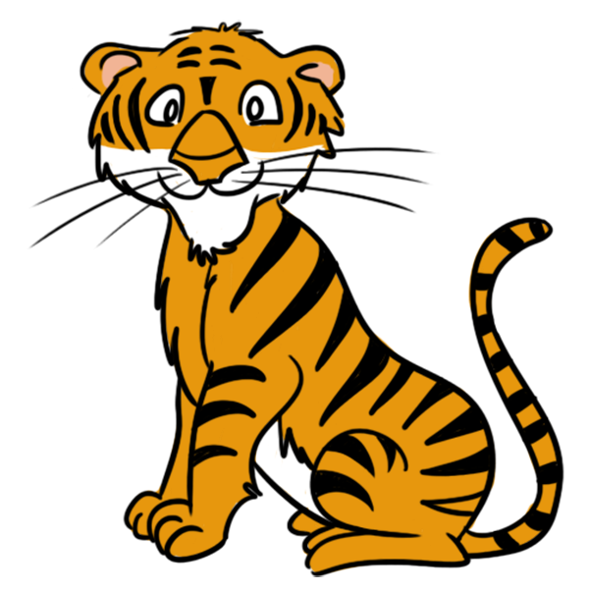  Notes For Parents.  Please bring the following to the school for your child (as soon as possible):  An Ipad will be sent home with your child. I would like you to take a little video of your child in rooms of the house doing activity associated with that room. This enables the children to observe and listen to different rooms of the house. We will play this in the classroom for the class to observe each child in their own home.  Items for the Colour Display Table:  Orange items: e.g. An orange toy

